Computer Networks Lab Report
Experiment 3: Router Configuration
Submitted By
SURIYA TS
RA2411030050051
Under the guidance of
Dr. Mallika
(Assistant Professor, School of Computing)
in partial fulfilment for the award of the degree
of
BACHELOR OF TECHNOLOGY
in
DEPARTMENT OF COMPUTER SCIENCE AND ENGINEERING WITH CYBER SECURITY
of
FACULTY OF ENGINEERING AND TECHNOLOGY

SRM INSTITUTE OF SCIENCE AND TECHNOLOGY,
TIRUCHIRAPPALLI
Academic Year: 2026–2027
Date: 23 October 2026

COMPUTER NETWORKS LAB
Experiment 3
Router Configuration (Creating Passwords, Configuring Interfaces)
Name: Suriya TS Reg. No.: RA2411030050051 Date: 23 October 2026

1. Experiment Title
Router Configuration: Creating Passwords and Configuring Interfaces on a Cisco 1941 Router using Cisco Packet Tracer.

2. Aim
To configure a Cisco router by creating console, enable and VTY passwords and by assigning IP addresses to its interfaces, and to verify connectivity between two networks connected through the router.

3. Software Requirements
- Cisco Packet Tracer (network simulation software)
- Devices used: one Cisco 1941 router (Router0) and two end devices, PC3 and PC4 (PC-PT)
- Connections: copper straight-through cables

4. Theory
A router forwards packets between different IP networks. Each router interface that connects to a network must be given an IP address belonging to that network, and the interface must be enabled with the no shutdown command. The router interface address then serves as the default gateway for the hosts on that network.
Access to the router is protected using passwords. The console password protects the console line (line console 0), the VTY password protects remote Telnet/SSH sessions (line vty 0 4), and the enable password protects access to privileged EXEC mode. The login command makes a line ask for its password.
The command show ip interface brief gives a summary of every interface, showing its IP address, whether the address was assigned manually, and its Status (physical layer) and Protocol (data link layer). An interface that is working correctly shows up in both columns.

5. Network Topology
The topology contains one Cisco 1941 router connected to two PCs. PC3 is connected to GigabitEthernet0/0 (network 192.168.1.0/24) and PC4 is connected to GigabitEthernet0/1 (network 192.168.2.0/24).
The connected topology is shown in Figure 2 (Step 2 of the procedure).

6. Procedure

Step 1: Place the devices
Open Cisco Packet Tracer and place a Cisco 1941 router and two PCs (PC3 and PC4) on the logical workspace.
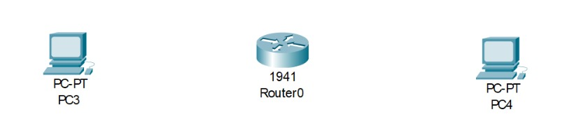
Figure 1: Cisco 1941 router (Router0) and two PCs (PC3 and PC4) placed in the workspace

Step 2: Connect the devices
Select Copper Straight-Through cable and connect PC3 and PC4 to the router. Red triangles on the links indicate that the connections are not yet active because the router interfaces are still shut down.
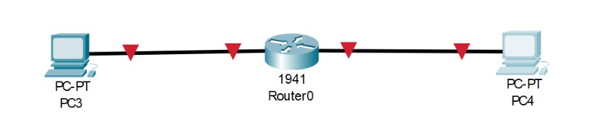
Figure 2: PC3 and PC4 connected to Router0 using copper straight-through cables

Step 3: Open the router CLI
Click Router0 and open the CLI tab. Answer no to the initial configuration dialog and press RETURN to get the Router> prompt.
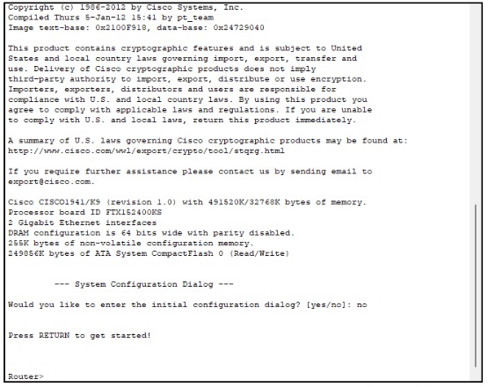
Figure 3: Router0 CLI showing the startup messages and the Router> prompt (initial configuration dialog answered "no")

Step 4: Configure the passwords
Enter privileged EXEC mode using enable and then global configuration mode using configure terminal. Set the console password, the enable password and the VTY password as shown below. The password used in the experiment is cisco.
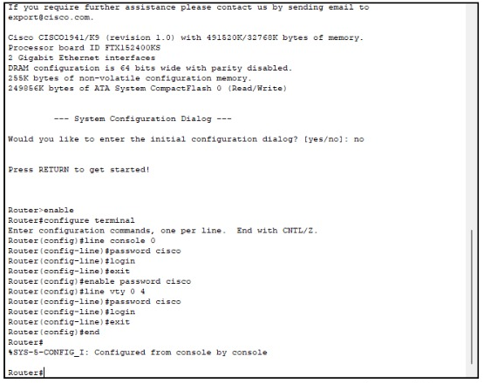
Figure 4: Console, enable and VTY password configuration on Router0

Step 5: Configure the router interfaces
Assign IP address 192.168.1.1/24 to GigabitEthernet0/0 and 192.168.2.1/24 to GigabitEthernet0/1, and enable both interfaces with no shutdown. The router reports both interfaces changing state to up.
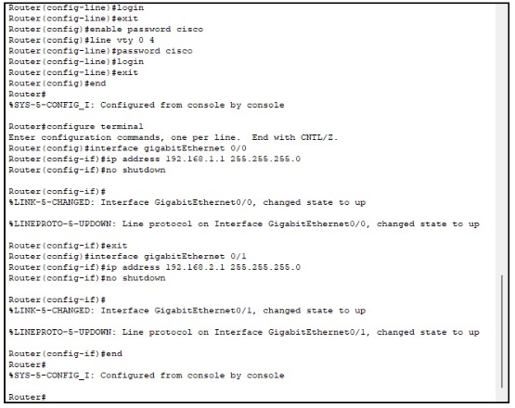
Figure 5: Configuration of GigabitEthernet0/0 and GigabitEthernet0/1 on Router0

Step 6: Verify the interfaces
Return to privileged EXEC mode and run show ip interface brief to check the IP addresses and the status of the interfaces.
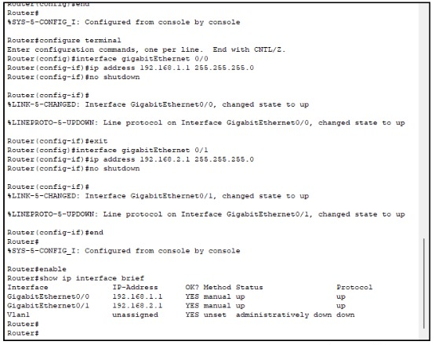
Figure 6: Output of the show ip interface brief command on Router0

Step 7: Configure PC3
Open PC3, go to Desktop > IP Configuration, select Static and enter IP address 192.168.1.2, subnet mask 255.255.255.0 and default gateway 192.168.1.1.
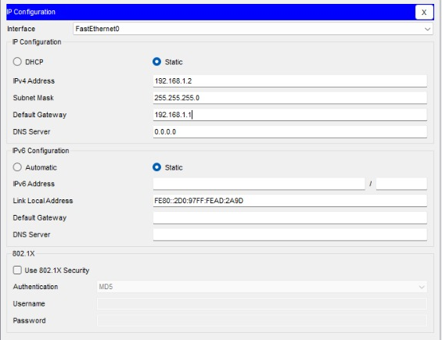
Figure 7: IP configuration of PC3

Step 8: Configure PC4
Open PC4, go to Desktop > IP Configuration, select Static and enter IP address 192.168.2.2, subnet mask 255.255.255.0 and default gateway 192.168.2.1.
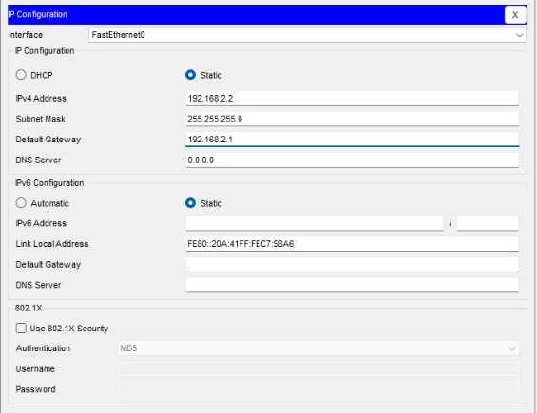
Figure 8: IP configuration of PC4

Step 9: Test connectivity
Open the Command Prompt on PC3 (Desktop > Command Prompt) and ping PC4 (192.168.2.2).
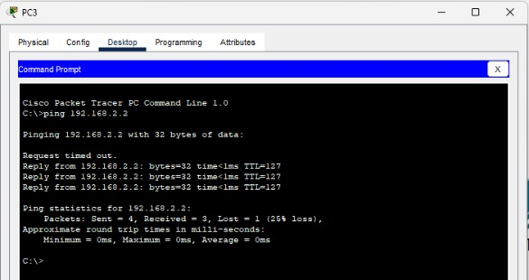
Figure 9: Ping from PC3 to PC4 (192.168.2.2) through Router0

7. Router Configuration Commands

7.1 Password configuration
Router>enable
Router#configure terminal
Router(config)#line console 0
Router(config-line)#password cisco
Router(config-line)#login
Router(config-line)#exit
Router(config)#enable password cisco
Router(config)#line vty 0 4
Router(config-line)#password cisco
Router(config-line)#login
Router(config-line)#exit
Router(config)#end

7.2 Interface configuration
Router#configure terminal
Router(config)#interface gigabitEthernet 0/0
Router(config-if)#ip address 192.168.1.1 255.255.255.0
Router(config-if)#no shutdown
Router(config-if)#exit
Router(config)#interface gigabitEthernet 0/1
Router(config-if)#ip address 192.168.2.1 255.255.255.0
Router(config-if)#no shutdown
Router(config-if)#end

7.3 Verification command
Router#enable
Router#show ip interface brief

8. IP Address Configuration Table
Table 1: IP addressing used in the experiment
Device | Interface | IP Address | Subnet Mask | Default Gateway
Router0 (1941) | GigabitEthernet0/0 | 192.168.1.1 | 255.255.255.0 | N/A
Router0 (1941) | GigabitEthernet0/1 | 192.168.2.1 | 255.255.255.0 | N/A
PC0 (PC3) | FastEthernet0 | 192.168.1.2 | 255.255.255.0 | 192.168.1.1
PC1 (PC4) | FastEthernet0 | 192.168.2.2 | 255.255.255.0 | 192.168.2.1
Note: In Packet Tracer the two PCs are labelled PC3 and PC4 (referred to as PC0 and PC1 in the experiment).

9. Testing and Verification

9.1 show ip interface brief
This command displays a summary of the router interfaces. In Figure 6 the output is:
Table 2: Output of show ip interface brief (Figure 6)
Interface | IP-Address | OK? | Method | Status | Protocol
GigabitEthernet0/0 | 192.168.1.1 | YES | manual | up | up
GigabitEthernet0/1 | 192.168.2.1 | YES | manual | up | up
Vlan1 | unassigned | YES | unset | administratively down | down

Both GigabitEthernet interfaces show the manually assigned addresses and are up in both the Status and Protocol columns, which confirms that they are enabled and the cables are connected correctly. Vlan1 has no IP address and is administratively down, which is its default state and does not affect this experiment.

9.2 Ping test
PC3 (192.168.1.2) pinged PC4 (192.168.2.2) as shown in Figure 9. The first request timed out, and the next three replies were received with time <1 ms and TTL=127. The ping statistics show 4 packets sent, 3 received and 1 lost (25% loss). The first request timeout is commonly seen when the devices have not yet learned each other’s MAC addresses (ARP), and the replies that follow show that PC3 can reach PC4 through the router. The TTL of 127 indicates that the packet passed through one router.

10. Result
The Cisco 1941 router was configured with console, enable and VTY passwords, and its GigabitEthernet0/0 and GigabitEthernet0/1 interfaces were configured with the IP addresses 192.168.1.1/24 and 192.168.2.1/24. Both interfaces were verified as up/up, and PC3 successfully communicated with PC4 across the router.

11. Conclusion
In this experiment, basic router configuration was carried out in Cisco Packet Tracer. Passwords were created to secure access to the router, interfaces were assigned IP addresses and enabled, and the configuration was verified using show ip interface brief and a ping test between the two networks. The experiment showed that a router with correctly configured interfaces and hosts with the proper default gateway can connect two different IP networks.

